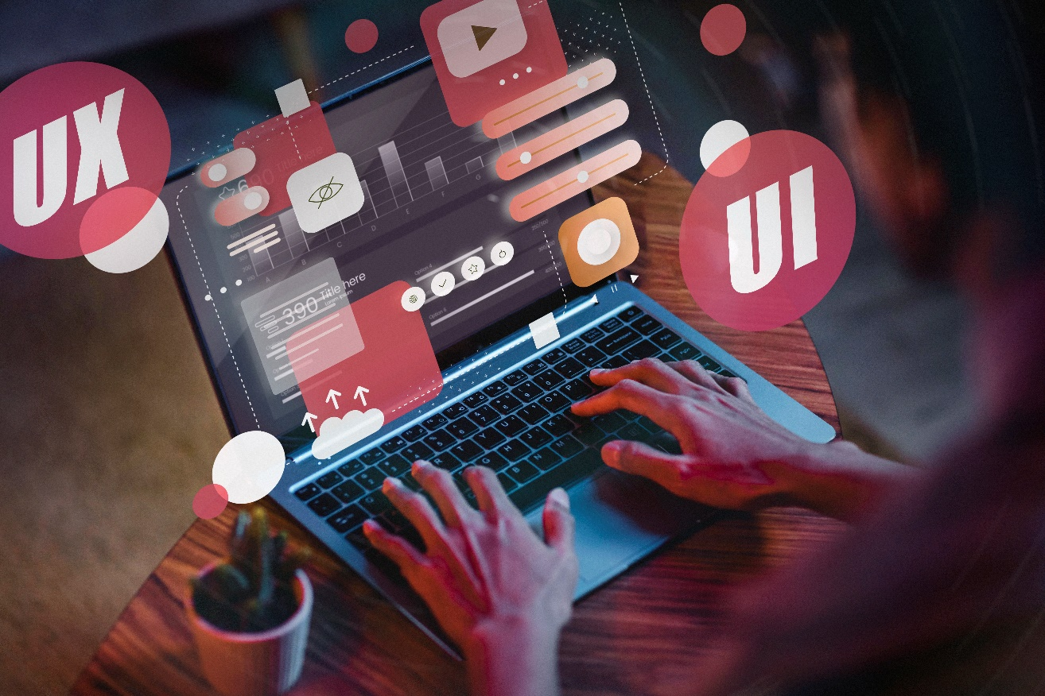

Group Project

IDEAS

**Health-Optimized Food Locator Platform**

# Problem Statement

Many individuals have specific dietary needs or restrictions due to health conditions such as Irritable Bowel Syndrome(IBS), gastritis, allergies, or personal choices such as veganism. Finding suitable food options when dining out or grocery shopping can be challenging and time-consuming. While North American countries pay special attention to those conditions, most Sri Lankans overlook them. This lack of attention in Sri Lanka makes it particularly difficult for individuals with dietary restrictions to find appropriate food options.

# Proposed Solution

Creating a web application that helps people find safe food options, customized to their health requirements and preferences quickly and efficiently.

# People Involved

* Users
* Restaurants / Cafes
* Administrators

# Functionalities

## Users

* Create profile
* Search by restaurants, cafes
* Directions to restaurants, cafes
* Search by dietary needs or preferences
* View details about menus, locations, user reviews, etc
* Review
* Save favorites

## Restaurants / Cafes

* Profile Creation
* Update Menus
* Respond to Reviews

## Administrators

* Manage content
* Manage user accounts
* Moderate reviews

## Uniqueness

Although several restaurants and cafes offer customizable food options that are safe for customers with health conditions, there are no platforms in Sri Lanka to find them. This would also help promote the specific places that offer these options and encourage people to be aware of their health conditions and be healthy.

**Platform for Doners to Make Donations to Hospitals in Sri Lanka**

**Problem Statement**

There are so many necessities in public hospitals in Sri Lanka. Apart from government fundings there are lot of doners who make donations to these hospitals. Currently doners get information about these necessary donations through phone calls or emails.

**Proposed Solution**

Creating a web application that is operated through hospitals so that hospitals can post necessities so that the public can see them and accept them to fulfill them to their ability. These donations can be categorized as

* Meal Donations
* Hospital Equipment
* Blood donations or Organ Donations
* Medicine donations
* Fulfillment of Make a Wish requests

**People Involved**

* Patients
* Hospital Administration
* Doners

**Functionalities**

1. Patients

* View profiles
* Share their recovery Journey if they are willing
* Connect with the doners

1. Hospital Administration

* Create profile for hospital
* Create profiles for patients
* Verify the information on the profile
* Post patients requests or necessities for patient
* Make requests about other things needed in the hospital

1. Doners

* Create profiles
* View Patient’s profile
* Make payments via the system
* Reserve mealtimes if they want to give meals to the patients
* Track donations

**Uniqueness**

Currently most of these things are done through social media and there could be many misinformation and frauds can happen. There are no platforms that are made specifically for this purpose. And also system like this makes the donation process way easier so that the doners can get an idea what is really necessary rather than making assumptions.

**Parent Tips for Children Platform**

# Problem Statement

Many children around the world lose their parents due to various reasons such as accidents, diseases, or conflicts. These children often miss out on the crucial life tips, advice, and guidance that parents typically provide. This can hinder their personal development, decision-making skills, and overall well-being.

# Proposed Solution

We propose a website, aimed at providing children who have lost their parents with essential life tips and guidance. This platform will offer practical advice on various aspects of life, mimicking the kind of support a parent would provide. The content will cover areas such as education, health, financial literacy, personal development, and emotional well-being.

# People Involved

* Children who lost their parents or have absent parents
* Caregivers and guardians
* Expertise content creators
* Mentors
* Administrators

# Functionalities

## Children

* Access to content
* Interactive Learning
* Ask a mentor

## - Community support Caregivers and guardians

* Caregiver tips
* Community support

## Content Creators

* Content Submission
* Engaging with children

## Mentors

* Scheduled Sessions
* Interact with children

## Administrators

* User management
* Content moderation

## Uniqueness

This website stands out by specifically targeting orphans and children who have lost their parents, providing them with comprehensive life tips and advice that address their unique needs. Unlike other educational platforms, it offers a wide range of practical, emotional, and educational content for personalized guidance. This approach ensures that these children receive the support they need to lead successful and fulfilling lives.